Liquid N2 for DMA Q800
THIS INSTRUMENT RREQUIRES TRAINING BY INSTRUCTOR
CONTACT TO :
SOP ver.1 (2022.02.02)
Risks !
- Suffocation / Don’t use elevator with N2 tank
- Suffocation of others / Don’t forget to lock elevator when you put N2 tank
- Frostbite / Wear proper protections (gloves, goggles)

License and elevator keys
- License to use N2 facility -> Anders
- Elevator keys -> Anders’ office

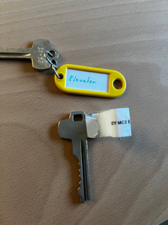
Route to N2 facility
- Lock elevator with key
- Push the destination
- Check the elevator start to go
- Go to destination using stair or another elevator
- Unlock elevator with key
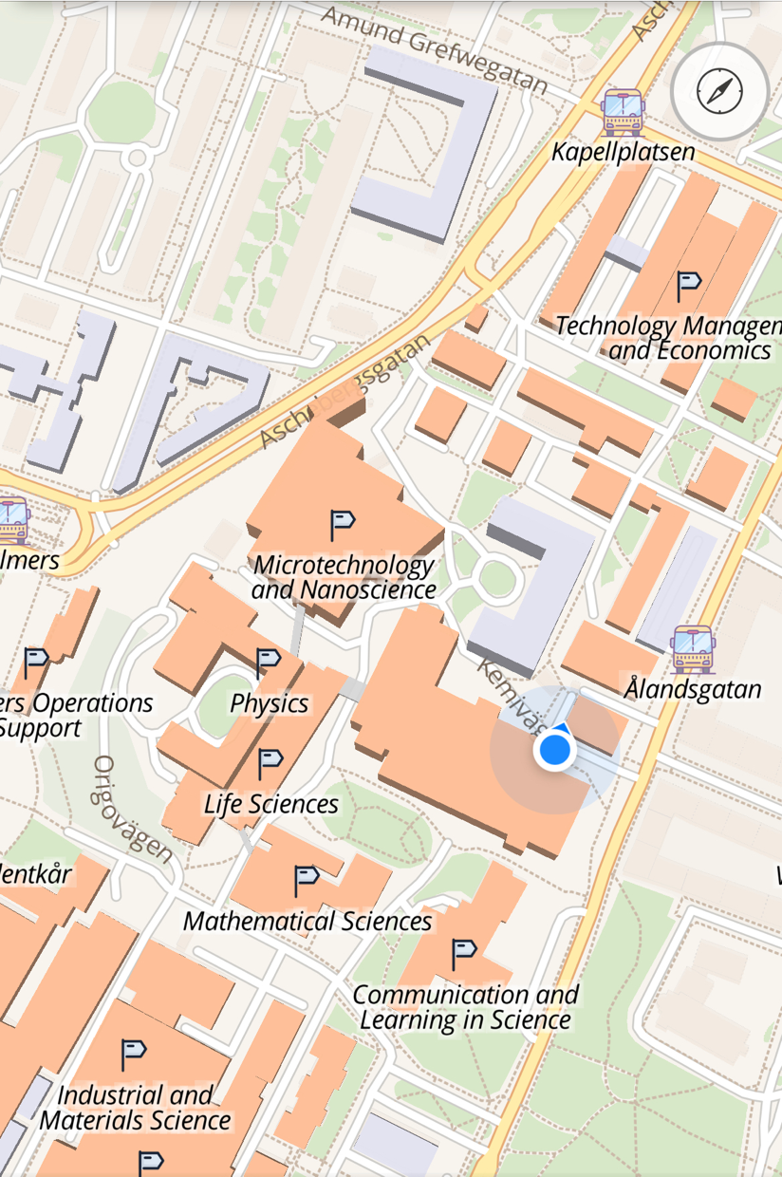
8th – 7th
7th – 0th
N2 facility
Process
- Disconnect liquid N2 tank from DMA
- Carry tank and filling tube to N2 facility (Check map and don’t forget to lock elevators)
- Connect tank and liquid N2 supply with filling tube
- Unlock liquid N2 supply with Licensed card and Pass Cord
- Fill liquid N2 (10-20 min)
- Fill log note book
- Disconnect tank and liquid N2 supply (Use a heat dryer to defrost)
- Bring back tank and filling tube (Check map and don’t forget to lock elevators)
- Connect tank and DMA

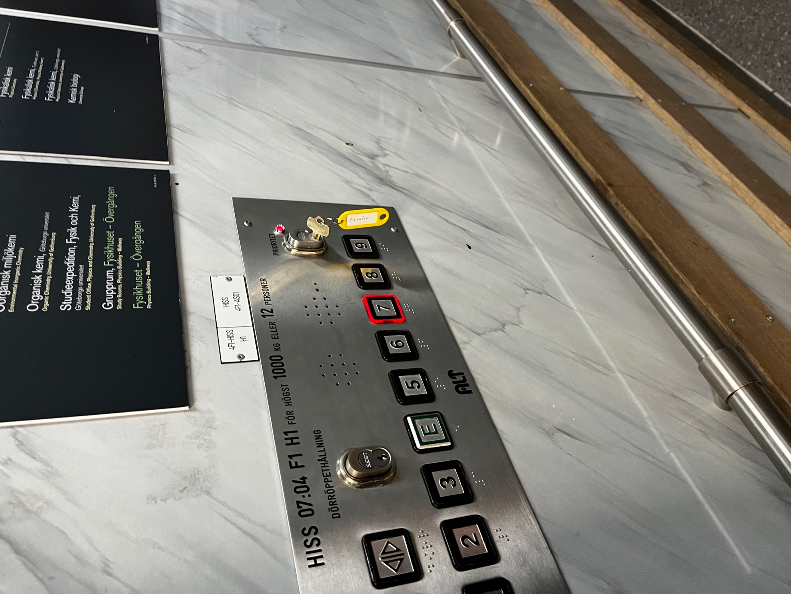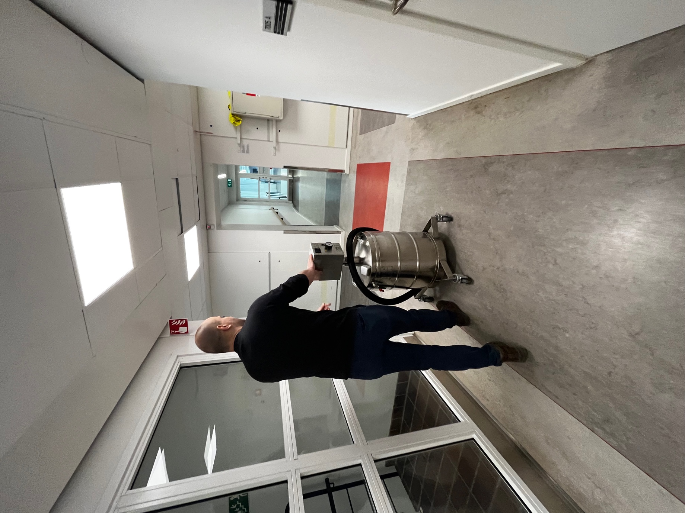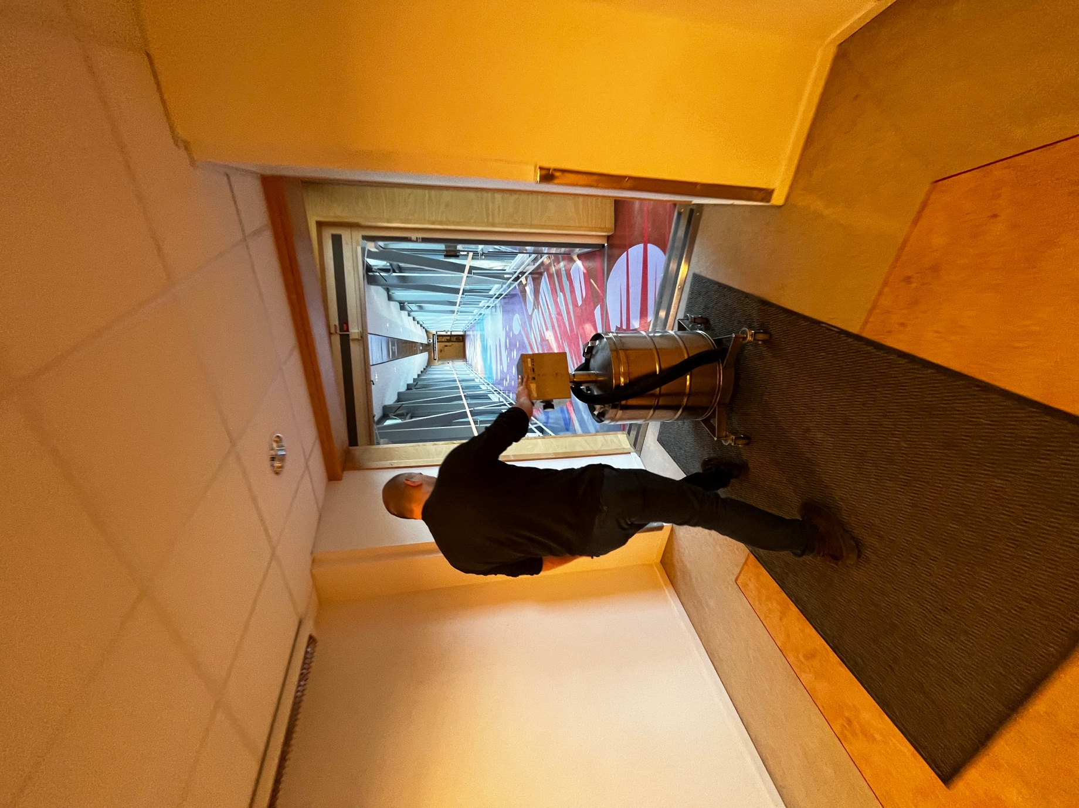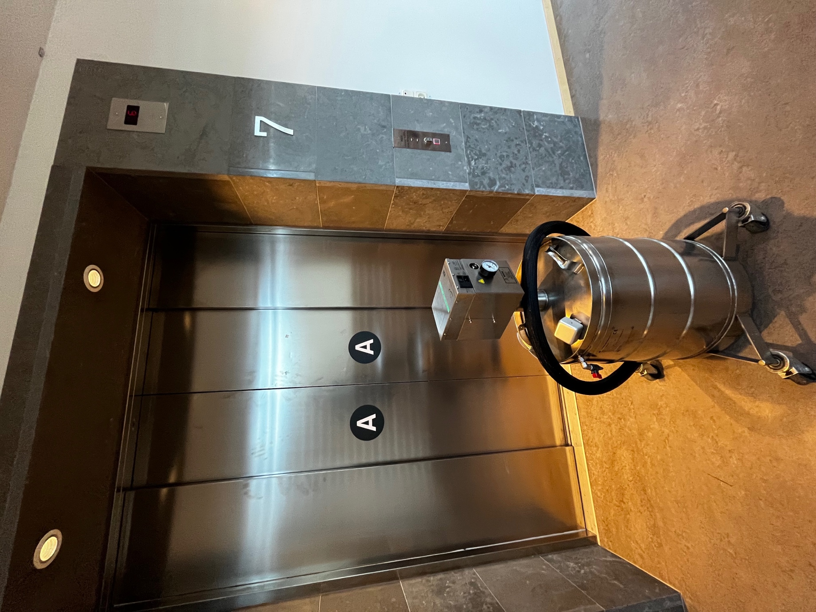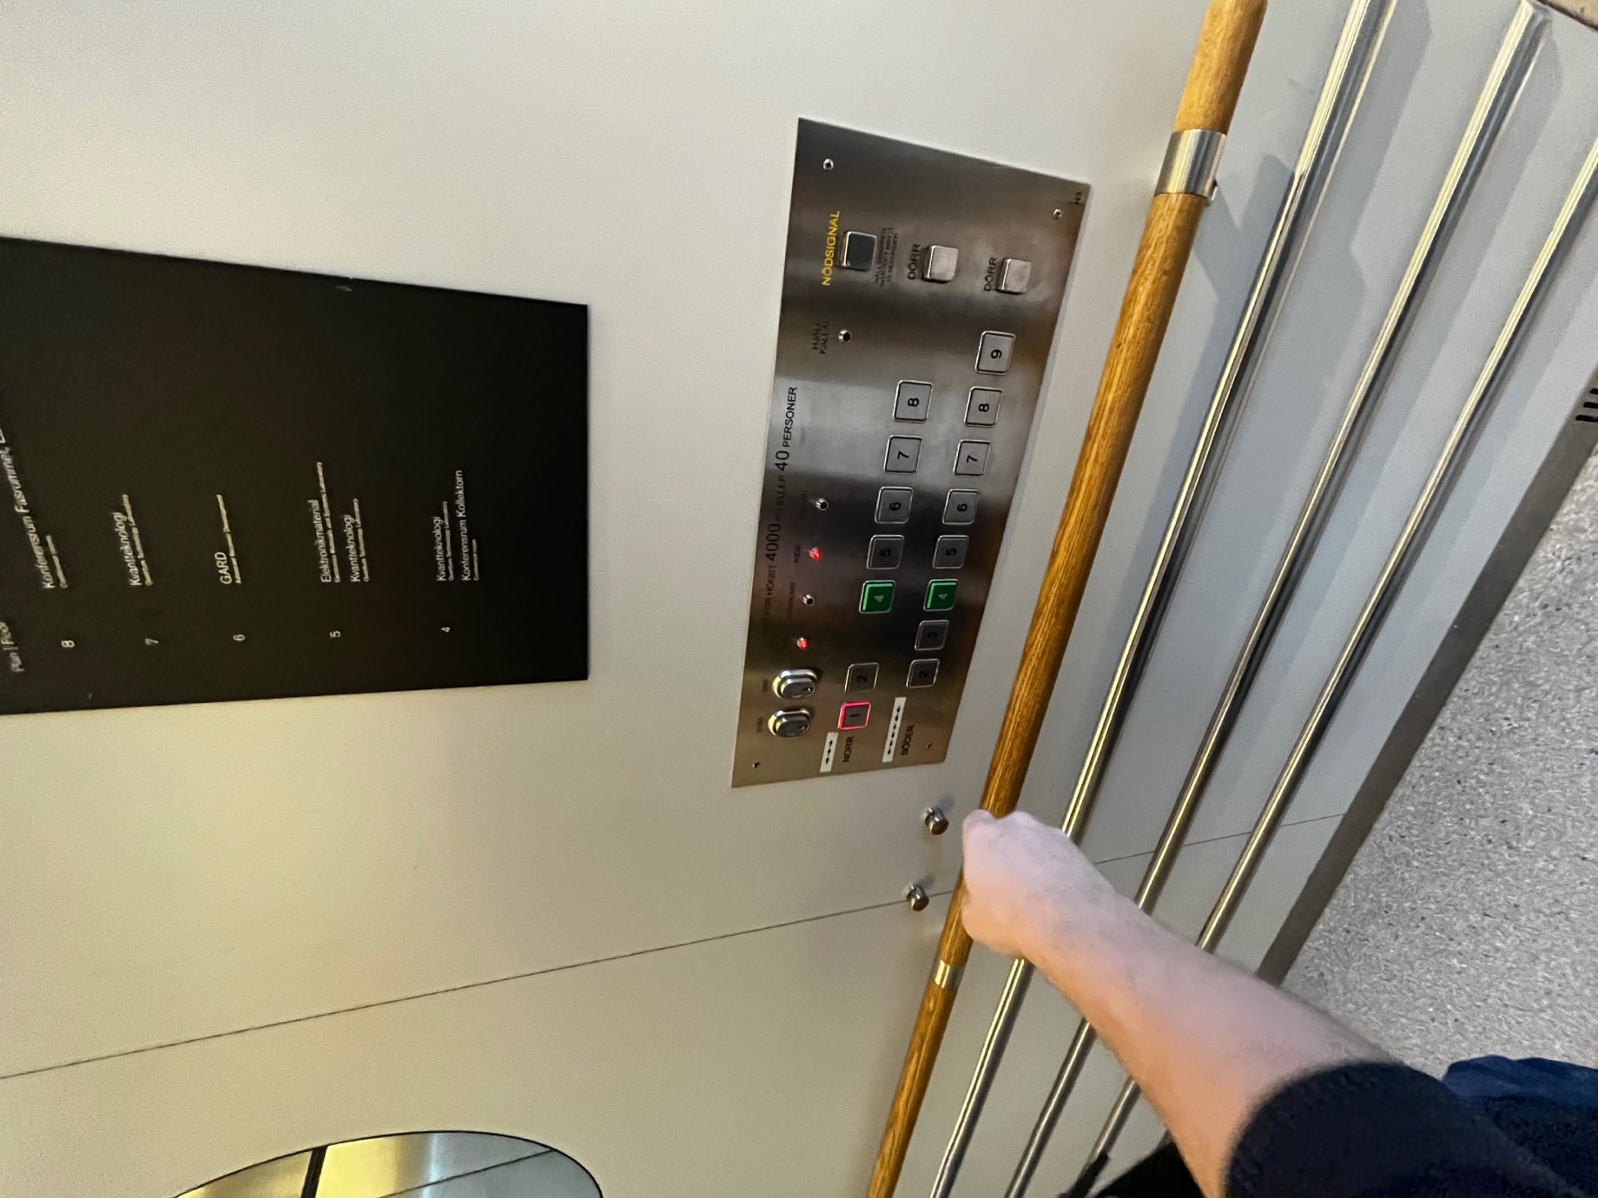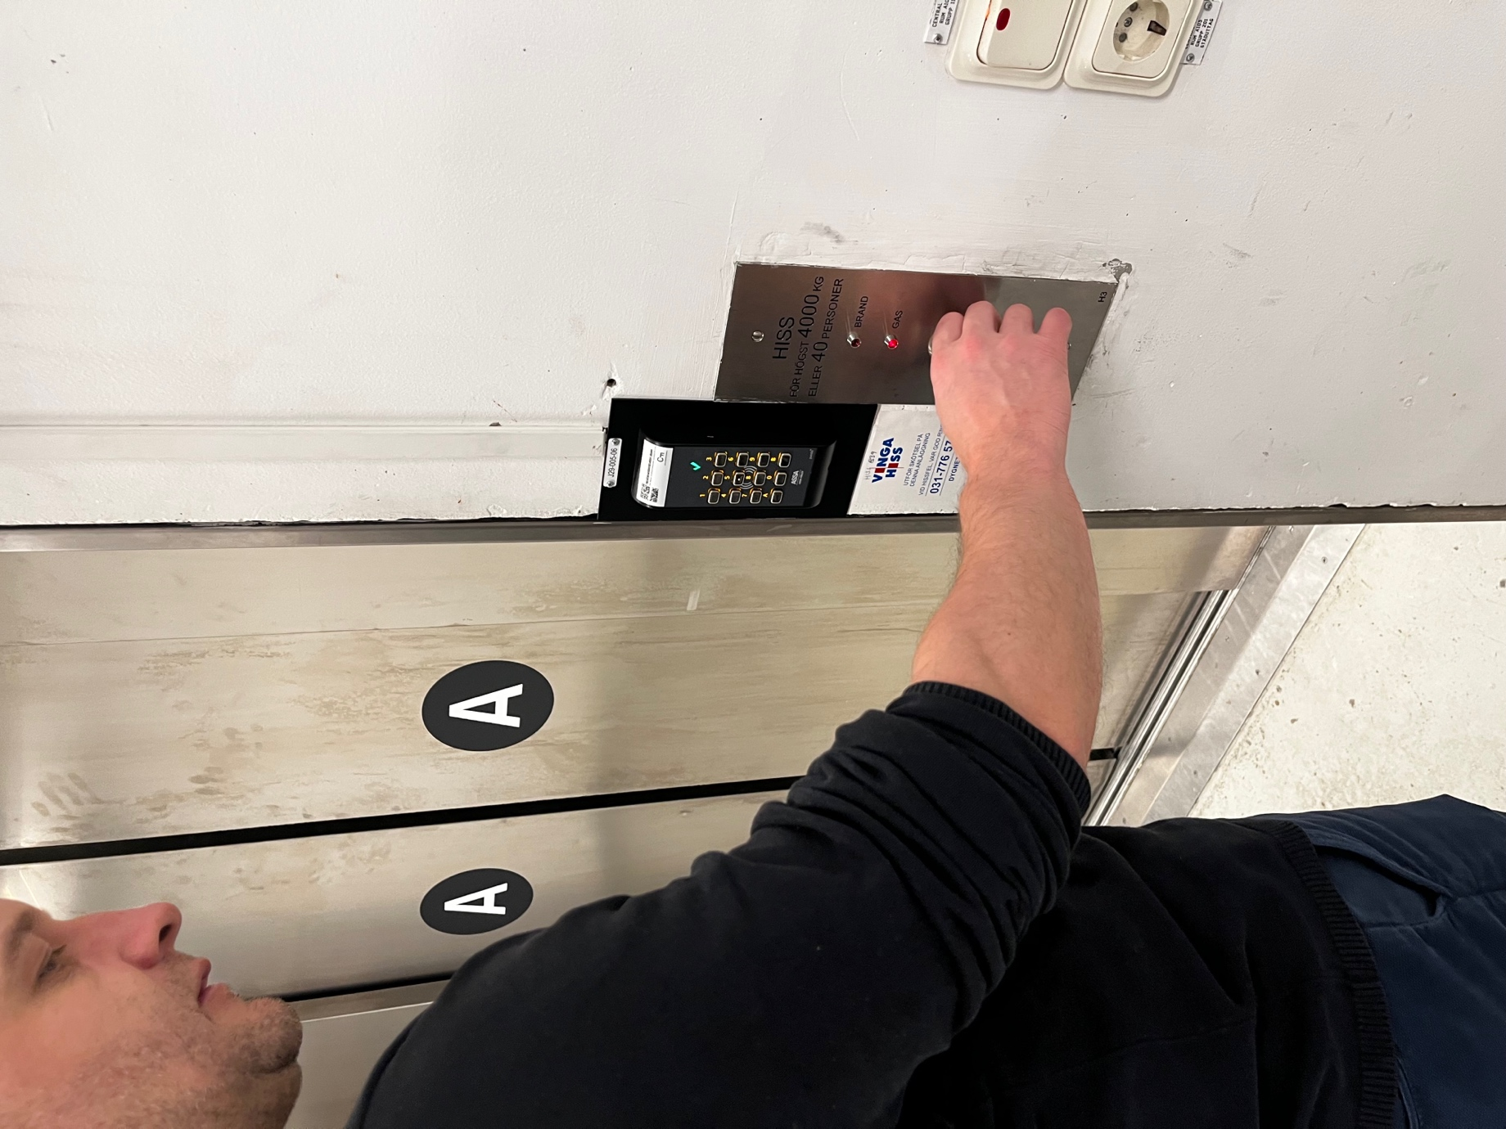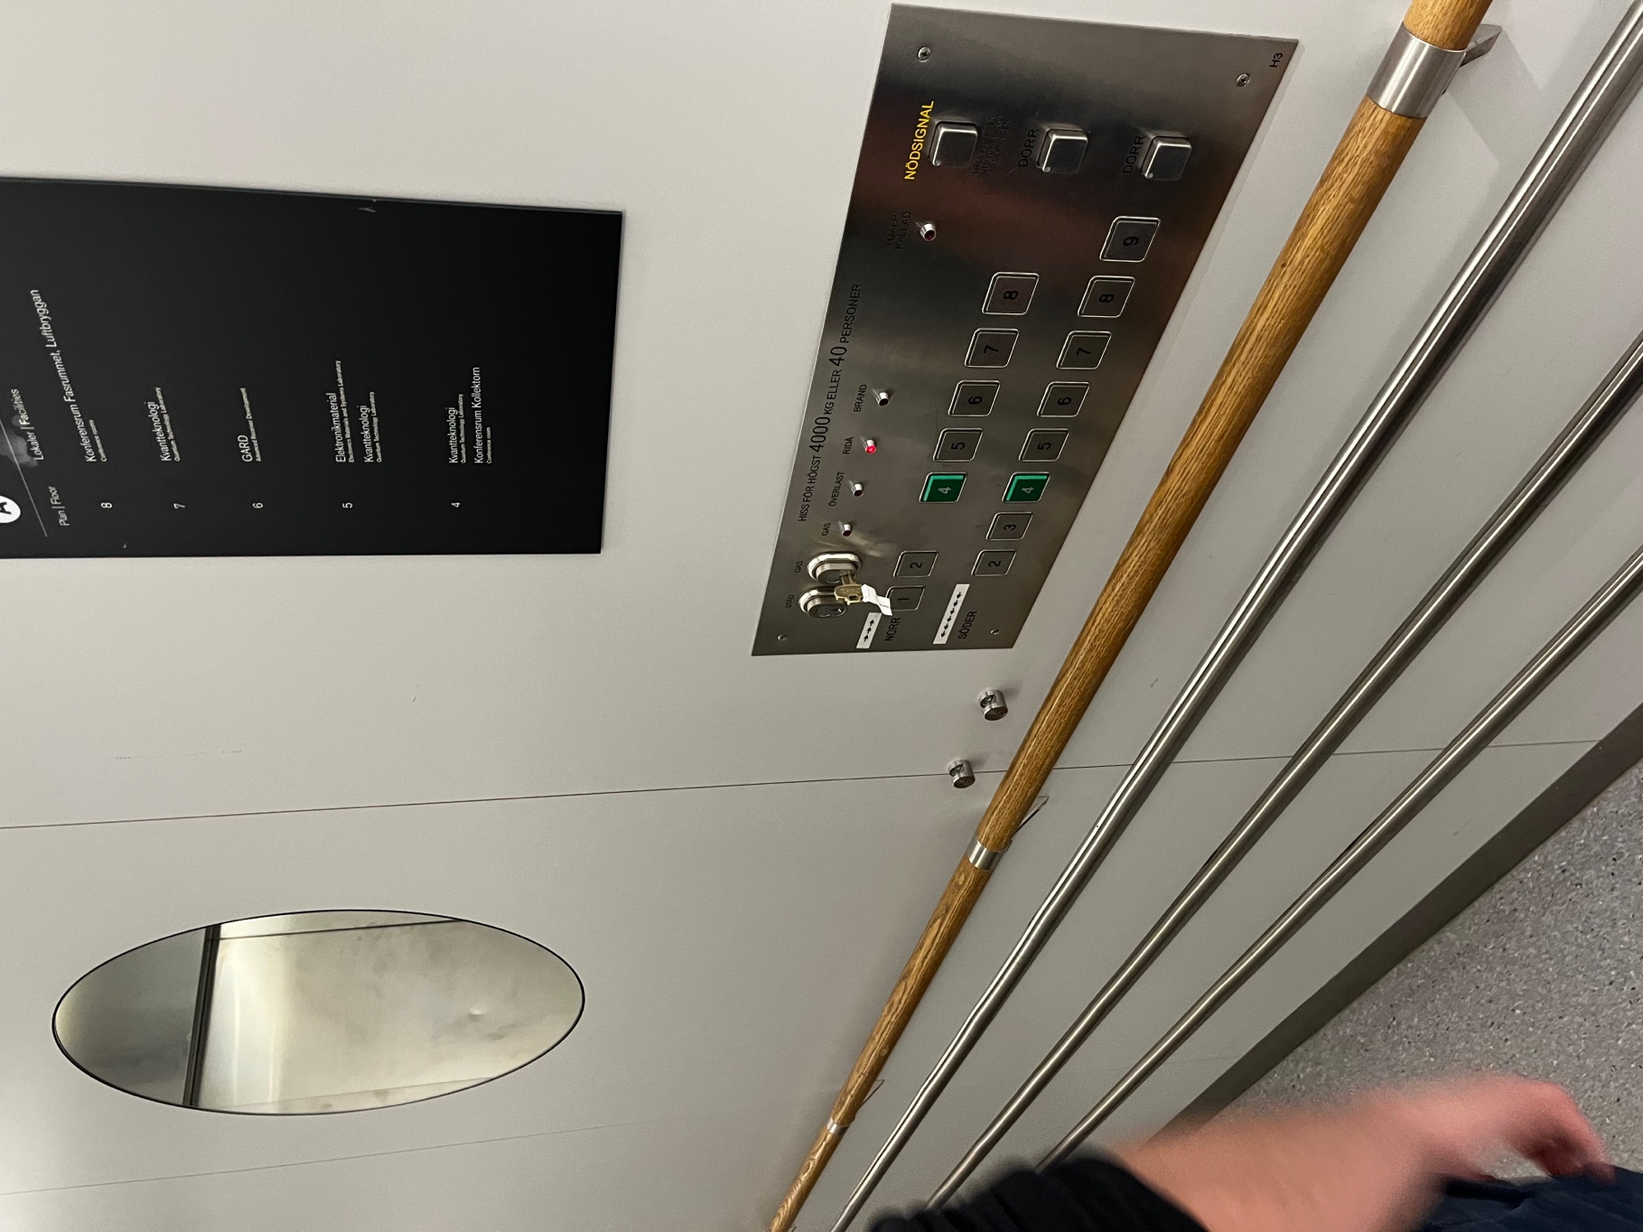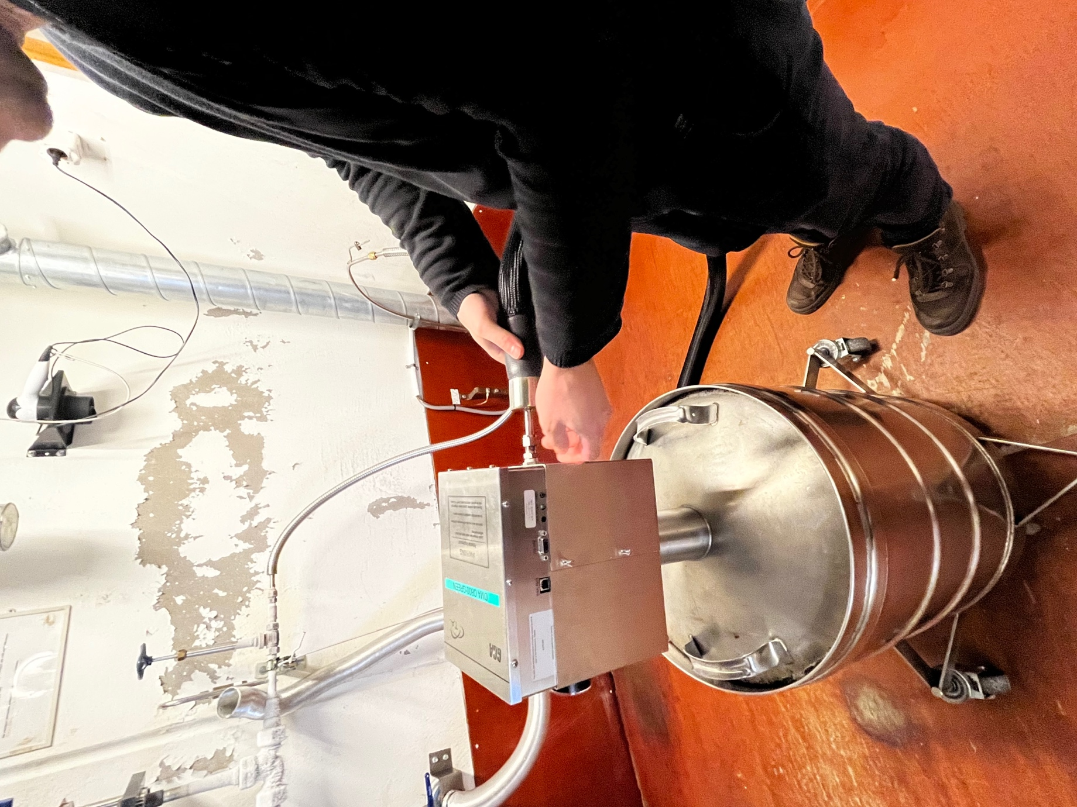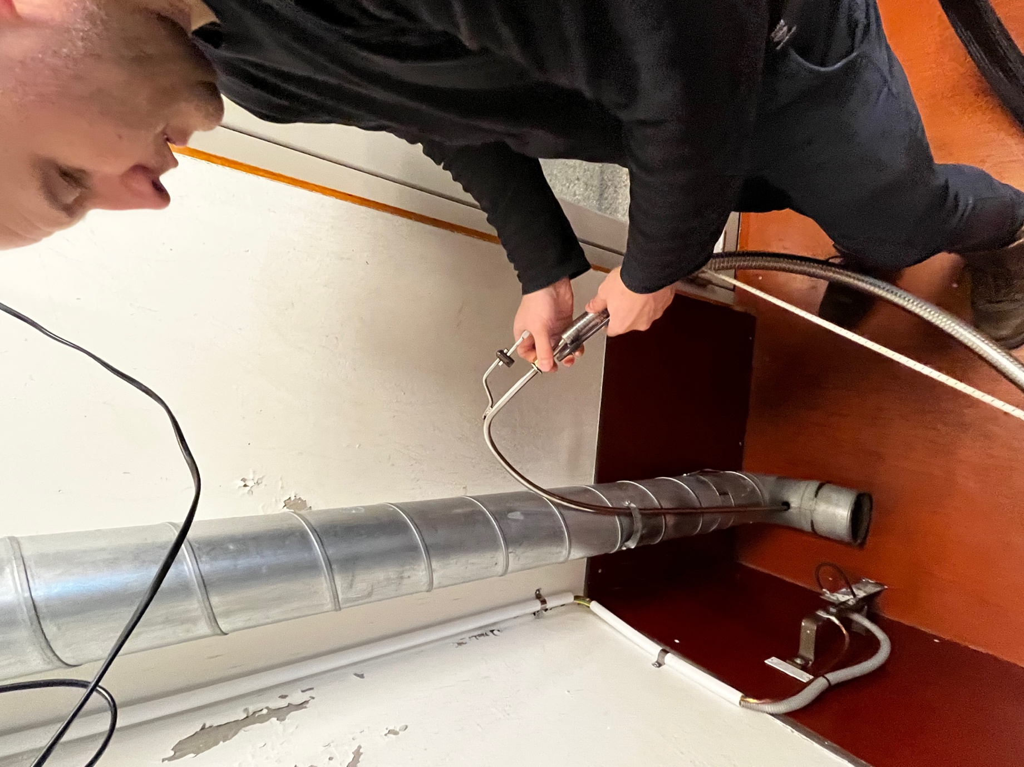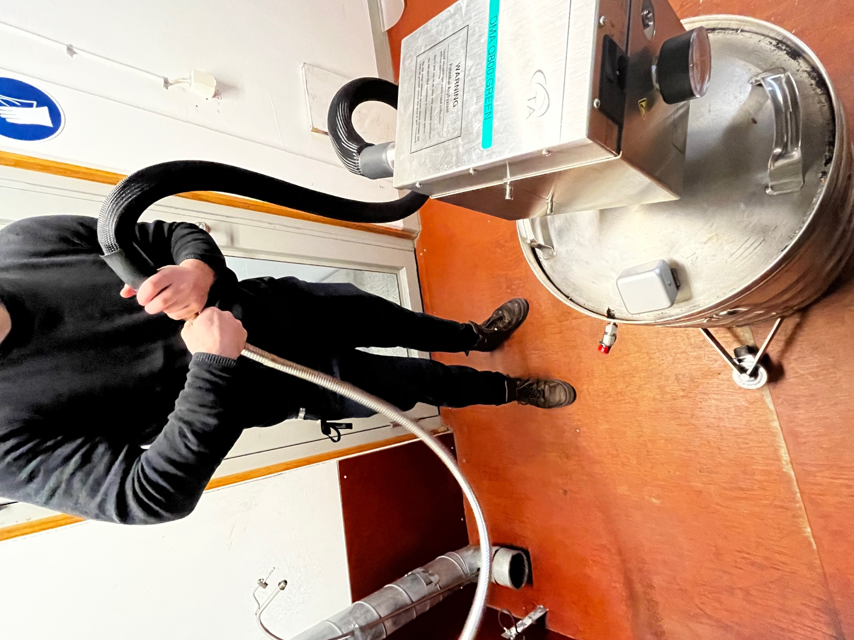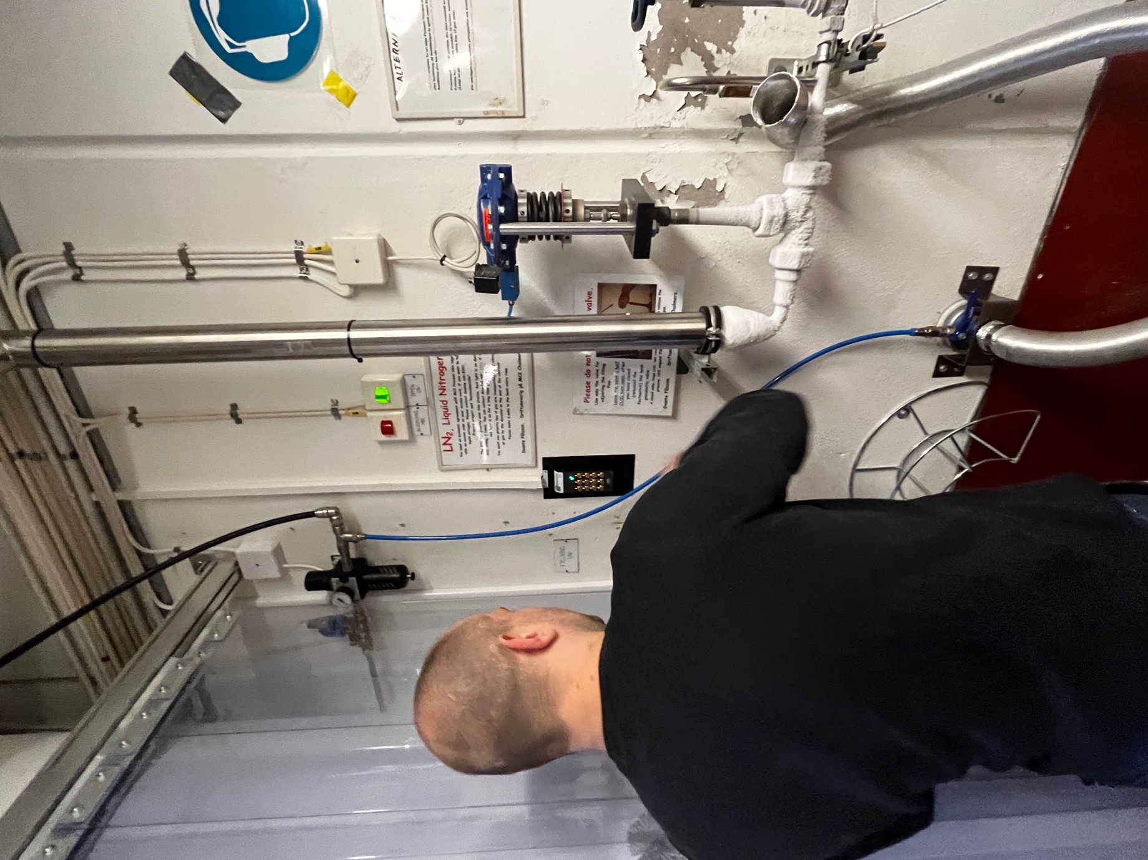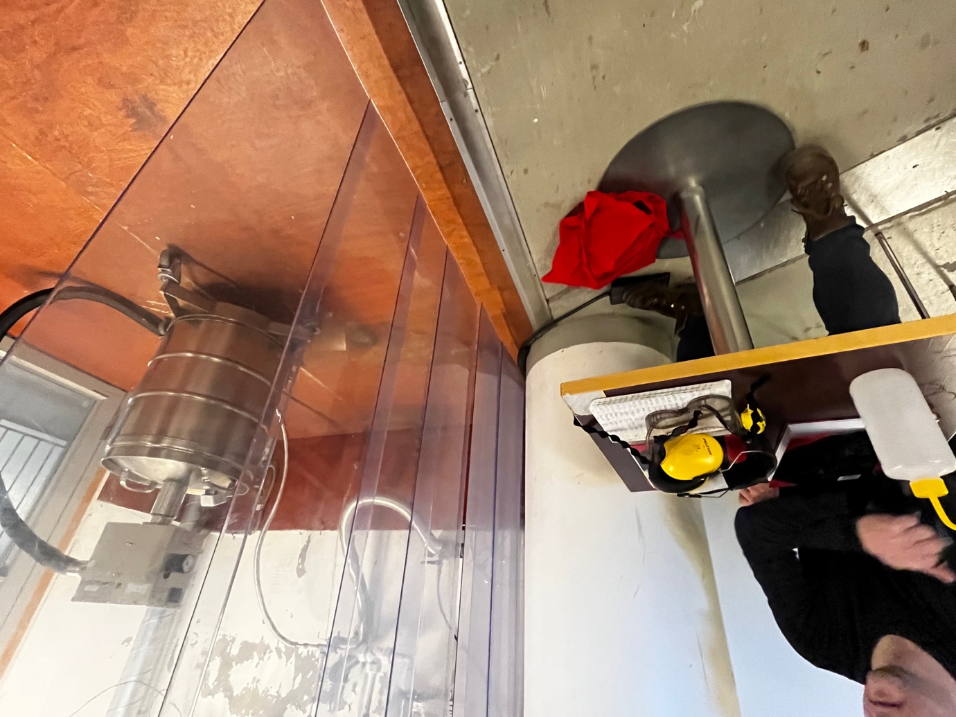

NOTIFY THE INSTRUMENT RESPONSIBLE OF ANY ERRORS OR MISFUNCTIONING

